Date: Jan 7, 2018

Site: Woodlands Trail
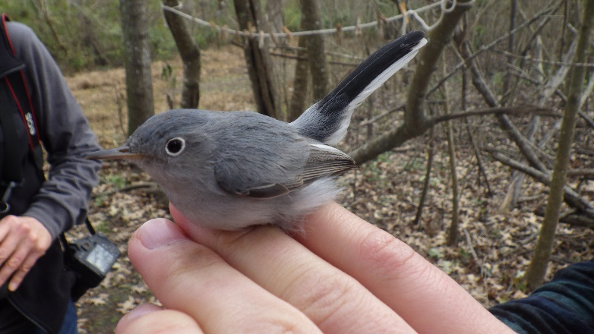

Volunteers/ Banders:
Emma DeLeon
Don Norman
Trey Hendrix
Lucia Havlovik
Aaron Hyde
Maureen McGuire
Paula Flynn
Warren James

Time/Conditions: 12 Nets were open from 6:50 until 12:35 under cool overcast conditions. Winds picked up during the last net round.

Capture Summary:
We captured 15 new birds, and recaptured 2 birds from a previous session.
We captured 7 species
Northern Cardinal
Ruby-crowned Kinglet
Orange Crowned Warbler
Myrtle Warbler
Blue-grey Gnatcatcher
Swamp Sparrow
Carolina Wren

Notes:
Today was a good banding day with a nice number and nice variety of wintering and resident species. With cold rainy weather (and even some snow!) the past few days we were glad to get a window of slightly warmer weather to band. Despite chilly conditions early we had more captures than a typical winter day. Perhaps birds were also happy to get a break in the weather as they were very active. We speculate that some birds (like the blue-grey gnatcatcher above) may have been foraging more vigorously and lower down near the nets than usual.

