Date: Jan 28, 2018

Site: Delacroix Preserve
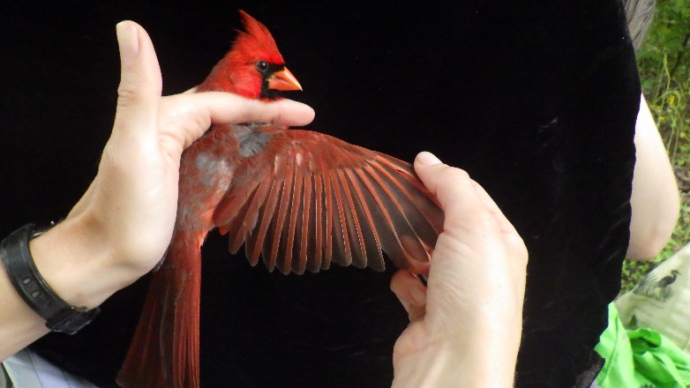

Volunteers/ Banders:
Emma DeLeon
Trey Hendrix
Warren James
Cody Richardson

Time/Conditions: 8 Nets were open from 7:26 until 12:20 under cool overcast/misty conditions. The site was very flooded so we were only able to open the nets at the back of the property.

Capture Summary:
We captured 1 new bird, and recaptured 2 birds from a previous session.
We captured 3 species
Northern Cardinal
Orange Crowned Warbler
Carolina Wren

Notes:
It was extremely flooded today after extensive rain all week with knee high water along most of the trail! We had a slow walk in and were only able to open 8 nets, BUT we did see a beaver swimming along the ditch and we were still able to catch a few birds. Extra thanks to the volunteers for braving some gnarly conditions!

